Pedestrian Detection

* The following code for detect Pedestrian…

1. import sys

print(sys.executable)

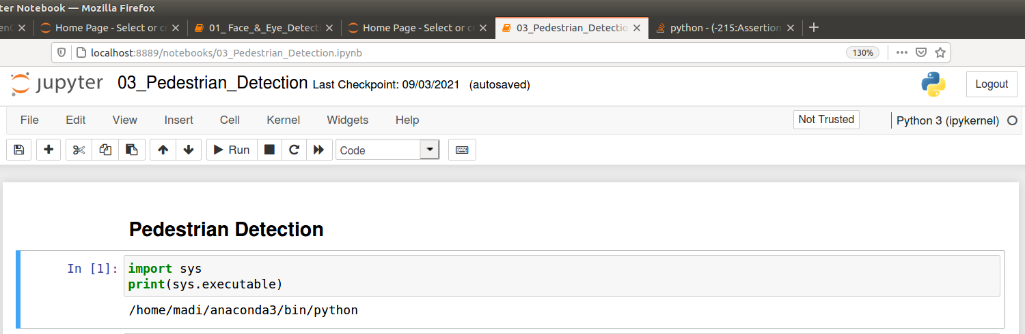

2. import cv2

import numpy as np

# Create our body classifier

body_classifier = cv2.CascadeClassifier('../../Haarcascades/haarcascade_fullbody.xml')

# Initiate video capture for video file

cap = cv2.VideoCapture('../../images/walking.avi')

# Loop once video is successfully loaded

while cap.isOpened():

# Read first frame

ret, frame = cap.read()

frame = cv2.resize(frame, None,fx=0.5, fy=0.5, interpolation = cv2.INTER_LINEAR)

gray = cv2.cvtColor(frame, cv2.COLOR_BGR2GRAY)

# Pass frame to our body classifier

bodies = body_classifier.detectMultiScale(gray, 1.2, 3)

# Extract bounding boxes for any bodies identified

for (x,y,w,h) in bodies:

cv2.rectangle(frame, (x, y), (x+w, y+h), (0, 255, 255), 2)

cv2.imshow('Pedestrians', frame)

if cv2.waitKey(1) == 13: #13 is the Enter Key

break

cap.release()

cv2.destroyAllWindows()

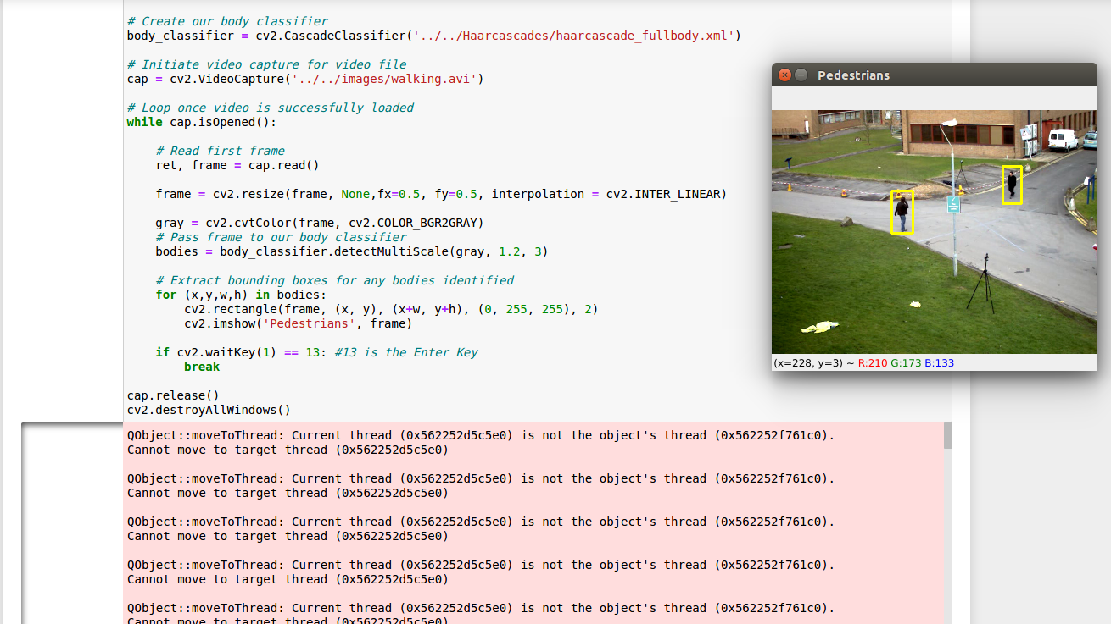

* Reference : <https://github.com/rchavezj/OpenCV_Projects>
* Name: Ramah Hashem Madi.